

**CCPC 2020 Practice Exam**

This is a closed book exam and 15 questions should be completed within 30 minutes. The answer key is provided at the end and should you have additional questions or clarification, please email your questions to [info@cannabispharmacist.org](mailto:info@cannabispharmacist.org) for discussion during the review session on 10/15/2020 at 7 pm EST. RSVP for the review session: <https://iscph.yapsody.com/event/book/591881/30657301>

1. In a study of 15 children with Autism and predetermined alpha level is 0.05, the study concludes 25 mg CBD improves behavioral symptoms. What does a p-value of 0.03 signify?

1. The results are statistically significant and clinically significant
2. The results are statistically significant, but not clinically significant
3. The results are not statistically significant, but clinically significant
4. The results are not statistically significant nor clinically significant
5. **None of the above are correct**

2. Consider the following placebo controlled trial using 10 mg THC in Parkinson’s; reports of dizziness in the active group were 25 of 100 participants and 10 of 75 in the placebo group. What is the Number Needed to Harm (NNH)?

1. 8.3
2. 25
3. **8**
4. 25.3

3. Which of the following CYP enzymes is a substrate of THC?

1. 3A4
2. 2C9
3. 2C19
4. 2D6
5. **I and II**
6. I and III
7. I, II and III
8. All of the above

4. The solution below is a total of 60 mL and 600 mg total per bottle. What is the suggested daily dose?

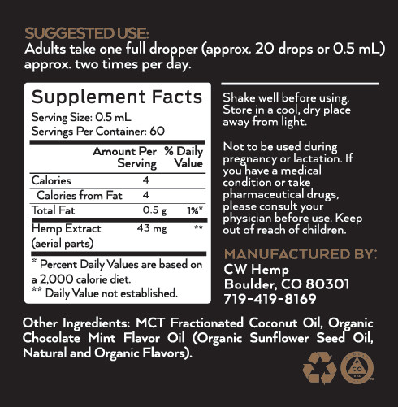

1. 60 mg
2. 5 mg
3. **10 mg**
4. None of the above

5. You dispense 3 prefilled vaporizer cartridges with 1 mL of oil each and an estimated 100 puffs per cartridge. If the patient is instructed to use 1 to 2 puffs every 4 hours, what is the estimated dispensed supply?

1. 3
2. 5
3. **25**
4. 30

6. According to peer-reviewed literature, which of the following statements is true?

1. 11-COOH-THC plasma concentrations after intrapulmonary THC administration are of major clinical importance
2. The variability of pharmacokinetics after oral administration is low
3. **There is no evidence that transdermal administration leads to absorption of cannabinoids into the blood**
4. Sublingual cannabinoid administration is absorbed significantly faster compared to oral administration

7. True or False: THC-dominant cannabis can be used therapeutically in the elderly without psychoactive adverse effects.

1. **True**
2. False

8. Which of the following patients is eligible for initiation of medical Cannabis therapy?

1. 48 year old male with active bipolar mania
2. **28 year old female with postpartum depression**
3. 69 year old male with uncontrolled angina
4. 88 year old female with bilateral pneumonia requiring hospitalization

9. Which of the following is a possible side effect of CBD?

1. Impairment
2. **Diarrhea**
3. Cough
4. None of the above are CBD side effects

10. Larry has stage 4 colon cancer and is seeking symptomatic relief of nausea and vomiting. He is unable to swallow anything without throwing up. Which of the following formulations should be avoided?

1. Sublingual tinctures
2. Vaporizers
3. Dry flower
4. **Capsules**

11. Dried cannabis flowers are subject to loss of potency when exposed to which of the following?

1. Air
2. Soil
3. Light
4. Freezing temperatures
5. I + II
6. **I + III**
7. I, III, IV
8. All of the above

12. Mary has recently started on CBD for Rheumatoid Arthritis and is worried about possible CBD drug interactions with her weekly methotrexate. What is the correct counseling?

1. CBD can inhibit methotrexate metabolism leading to increased methotrexate side effects
2. CBD can increase methotrexate metabolism leading to decreased methotrexate benefit
3. **Methotrexate is not metabolized by CYP enzymes so there is no additional counseling**
4. None of the above are correct

13. Amanda is using gabapentin 300 mg three times daily for neuropathy, alprazolam 2 mg twice daily for anxiety, and zolpidem at bedtime for insomnia. She wants to start medical cannabis for neuropathy management. What should she be counseled on considering her other medications?

1. Additive sedation and impairment
2. Possible hypotension and increased fall risk
3. Potential tachycardia mimicking anxiety
4. **All of the above**

14. Jake is experiencing intolerable impairment from his balanced (1:1) capsules. He is seeking an alternative enteral product that will preserve mental clarity. Which of the following are appropriate recommendations?

1. Switch to THC dominant capsules
2. Switch to vaporizer
3. **Switch to CBD dominant capsules**
4. None of the above are appropriate

15. Sue is a 86 year old female with chronic arthritis pain using 10 mg CBD twice daily. She has no relief with her current dose and is seeking an alternative recommendation. Sue seeks to avoid impairment and only wants an enteral product. Which of the following recommendations is appropriate?

1. **Increase to 20 mg twice daily**
2. Increase to 50 mg twice daily
3. Keep at 10 mg twice daily
4. Keep at 10 mg twice daily and add 10 mg THC at bedtime

**ANSWER KEY IS ON THE NEXT PAGE**

Answer Key

1. E
2. C
3. A
4. C
5. C
6. C
7. A
8. B
9. B
10. D
11. B
12. C
13. D
14. C
15. A