International Society of Cannabis Pharmacists Presents

Clinical Cannabinoid Pharmacy 2020

As a Member-based society, we are so fortunate to have such dedicated members to support our society’s Mission and Vision!

Thanks to our Peer Review Committee who ensured presentations were unbiased and contained relevant clinical information:

Tamer Elias

Mariah LaVere

Lauren Camarillo

Brielle Okulicz

David Katz

Natalie Schmitz

Sarah Dehoney

Margaret O’Connor

Reyan Schroter

Elaine Richter

Sabrina Griggs

Melani Kane

Aiya Almogaber

Joy Lawal

Sonya Frausto

Lauren Miller

Thank you to our Virtual Sponsors for supporting the role of the pharmacist:



MAKING CANNABIS MEDICAL
Course Details: Making Cannabis Medical
Link To Access Article:
https://cannabispharmacist.org/ccpc2020-mcm/

Link to Redeem CPE:
https://learn.ceimpact.com/login?redirUrl=/library/course/2244/h

Examine the required components that make Cannabis medical
- Describe the process to maintain pharmaceutical-grade medicine
- Define potential contaminants during various stages of medical Cannabis production
- Determine the importance of genetic consistency or variability when creating pharmaceutical preparations
- Summarize the role of the 2018 Farm Bill and the implications for hemp–based products
- Outline testing standards that ensure consistent and reliable products
- Evaluate the importance of traceability across the manufacturing and dispensing process
- Explain the various analytical tools used to determine safety and potency
- Summarize operating procedures for safe handling of Cannabis products to prevent diversion
- Illustrate the need for HIPAA-compliant record keeping requirements in medical dispensaries
- Review product labeling to determine chemical composition, concentration, and calculate days supplied

CLINICAL CANNABINOID BASICS
Course Details: Clinical Cannabinoid Basics
Link To View/Download Slides
https://drive.google.com/drive/folders/1YXaTP_wF6qVVnV7L_a_4OxobKqc8Zy61?usp=sharing

Link To View Recording (Part 1)
https://youtu.be/nDwZ8vbhxD8

Link To View Recording (Part 2)
https://youtu.be/a2Xq_SmfdTI

Link To Redeem On-Demand CE Credit:
https://learn.ceimpact.com/login?redirUrl=/library/course/2246/h

Part I: Endocannabinoids with Dr. Dustin Sulak, DO

Discover the structure and function of the Endocannabinoid System (ECS)
- Identify the principle mediators of the ECS
- Examine the functions of the Endocannabinoid system (ECS)
- Explain the theory of Clinical Endocannabinoid Dysfunction (CECD)

Part I: Phytocannabinoid Formulations and Pharmacodynamics with Dr. Linda Klumpers, PhD

Analyze the commonly used formulations and pharmacodynamic properties of major cannabinoids
- Examine the varying THC and CBD plasma concentration onset and duration of commonly available formulations
- Summarize the pharmacodynamic effects of major and minor cannabinoids in humans
- Explore the role of the entourage hypothesis

Part I: Cannabinoid Metabolism and Drug-Drug Interactions with Dr. Linda Klumpers, PhD

Determine clinically relevant drug-drug and drug-disease interactions
- Summarize the CYP450 pathways for major cannabinoids
- Identify clinically relevant drug-drug and drug-disease interactions with THC and CBD
- Recommend strategies to manage drug-drug and drug-disease interactions with medical Cannabis products

Part I: Cannabis in Palliative Care with Dr. Michael Ruggiero, PharmD

Evaluate the use of Cannabis medicine in palliative care
- Identify potential uses of Cannabis medicine
- Develop care plans for patients requiring palliative care using cannabinoid medicine for symptoms including: pain, nausea, vomiting, insomnia, spasms, and anxiety

Part I: Cannabis and Opioid Interactions with Dr. Dustin Sulak, DO

Propose medical Cannabis as an alternative to opioids for pain management
- Discuss the overlap between the endogenous opioid and endocannabinoid systems
- Justify the use of cannabis products including THC and CBD in various pain models
- Examine dosing schedules that reduce opioid use to promote multimodal pain management

Part II: Managing Cannabinoid Toxicity with Dr. Melani Kane, PharmD

Review and resolve medication therapies for potential toxicity
- Define cannabinoid-specific and formulation-specific adverse reactions
- Outline potential strategies to mitigate cannabinoid medicine toxicity

Part II: Incorporating Hemp/Cannabidiol in Your Clinical Practice with Dr. James Taylor, MD

Interpret the clinical role of hemp-based Cannabidiol in clinical practice
- Identify medical conditions that could benefit from hemp extractions
- Compare the advantages and disadvantages to available CBD formulations including isolates, broad-spectrum, and full-spectrum extractions
- Formulate a monitoring plan to determine safe and effective use of CBD

Part II: Patient Consultations; Osteopathic Perspective with Dr. Dustin Sulak, DO

Integrate medical Cannabis as a complementary or alternative therapy
- Develop a care plan for presenting patients from an osteopathic perspective

Part II: Patient Consultations; Pharmacist Perspective with Dr. Shane Carmichael, PharmD

Integrate medical Cannabis as a complementary or alternative therapy
- Develop a care plan for presenting patients from a pharmacist perspective

Part II: Case Discussion: Complex Patient Presentations

Design safe and effective treatment regimens for complex patient presentations
- Formulate appropriate initial recommendations for cannabis-naïve and experienced patients
- Construct alternative recommendations for patients experiencing formulation-specific or cannabinoid-specific adverse reactions

Part II: Day 1 Q&A
- Dustin Sulak, Linda Klumpers, Michael Ruggiero, Melani Kane, Shane Carmichael, James Taylor
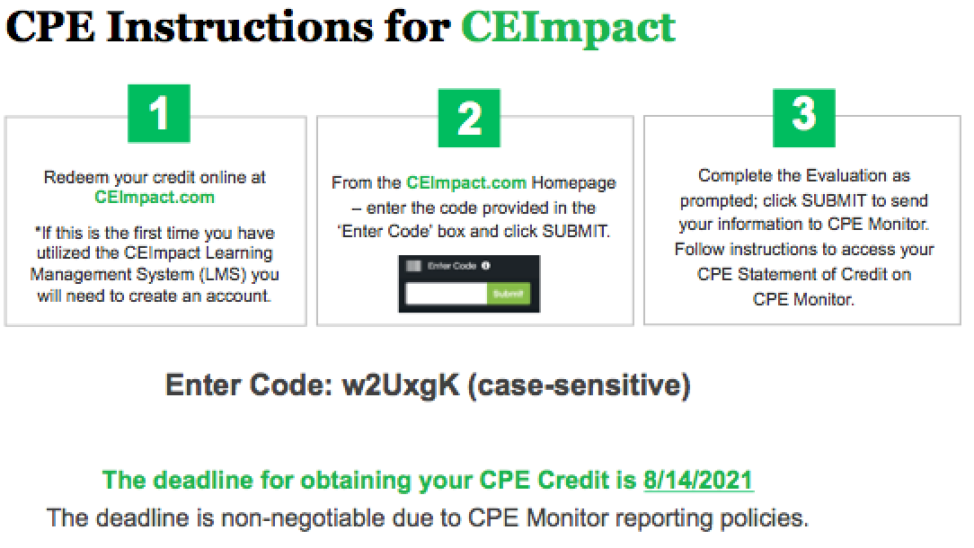

ADVANCED CLINICAL CANNABINOID CONSIDERATIONS
Course Details: Advanced Clinical Cannabinoid Considerations
Link To View/Download Slides
https://drive.google.com/drive/folders/1z-sVbxxTrIqh7NnG6E32AzSDHAtOJARa?usp=sharing

Link To View Recording (Part 1)
https://youtu.be/QkNwtkOubdo

Link To View Recording (Part 2)
https://youtu.be/ziecBFD2Nm8

Link To Redeem On-Demand CE Credit:
https://learn.ceimpact.com/login?redirUrl=/library/course/2247/h

Part I: Cannabis, Cognitive Functioning, and Mental Health with Dr. J Cobb Scott, PhD

Explain the neuropsychiatric implications of Cannabis use in various populations
- Identify the association of neurocognitive impairment in adolescent versus adult populations
- Compare functional MRI (fMRI) scans in recreational and medical Cannabis users and the implications to prevent harm
- Summarize the findings of the National Academy of Sciences, Engineering, and Medicine related to the development of Cannabis-induced anxiety, depression, schizophrenia, and bipolar mania.

Part I: Cannabis in Neurological Disorders with Dr. Stacia Woodcock, PharmD

Evaluate the role of phytocannabinoids in various degenerative and non-degenerative neurological disorders
- Summarize the literature surrounding medical cannabis in neurological disorders including; Multiple Sclerosis, Amyotrophic lateral sclerosis (ALS), Parkinson’s disease (PD), Huntington’s disease (HD), and Alzheimer’s disease (AD)
- Demonstrate the benefit versus risk of phytocannabinoids in various neurological disorders
- Relate the pharmacologic actions of phytocannabinoids to conventional therapies in neurological disorders

Part I: Cannabis in GI Disorders with Mr. Brian Essenter, RPh

Outline the role of cannabis medicine in gastrointestinal disorders
- Summarize the literature evaluating medical Cannabis in Crohn’s disease, ulcerative colitis, IBS, and liver disease
- Evaluate the use of common formulations in G/J tube

Part I: Special Populations: Pregnancy and Lactation with Dr. Laura Borgelt, PharmD

Evaluate the use of medical Cannabis in special populations including pregnancy and lactation
- Explain the role of the ECS during prenatal and perinatal phases
- Interpret the risk of cannabis products for developing bodies
- Analyze the presence of cannabinoids in breast milk following maternal consumption

Part II: Special Populations: Pediatrics with Dr. Bonni Goldstein, MD

Evaluate the use of medical Cannabis in special populations including pediatrics and young adults
- Identify potential pediatric conditions that could benefit from the use of medical Cannabis
- Compare the benefits and risks of phytocannabinoids; THC, CBD, CBG, CBN, and THCV in pediatric populations
- Construct initial dosing recommendations for pediatric patients with cancer, autism, pain, and epilepsy

Part II: Special Populations: Geriatrics with Dr. Dustin Sulak, DO

Evaluate the use of medical Cannabis in special populations including geriatrics
- Summarize the risks of medical Cannabis in geriatric populations
- Develop dosing algorithms for cannabis-naïve elderly patients

Part II: Cannabis in Exploratory Conditions with Dr. Kareem Abdalla, PharmD

Identify the potential relationship between the ECS and various exploratory conditions
- Illustrate the role of the ECS in conditions including psoriasis, solid organ transplant, bone marrow transplant, rheumatoid arthritis, and Tourette’s syndrome
- Demonstrate the potential interaction between Cannabis products and immunomodulators

Part II: Panel: Future of Cannabis Pharmacy Moderated by Dr. Melani Kane, PharmD with Laszlo Mechtler, MD and Dr. Christine Roussel, PharmD, BCOP

Interpret the future of Cannabis medicine and the role of the healthcare professional
- Explain the current legal landscape and regulatory challenges of Cannabis across the United States
- Evaluate the public perception and role of cannabinoids in medical models across the globe
- Identify challenges to standardization of medical products across state/country lines

Part II: Case Discussion: Special Populations

Design safe and effective palliative care regimens for special populations including pediatrics and geriatrics
- Formulate appropriate initial recommendations for sensitive populations including pediatrics and geriatrics
- Construct alternative recommendations for patients experiencing formulation-specific or cannabinoid-specific adverse reactions

Part II: Day 2 Q&A
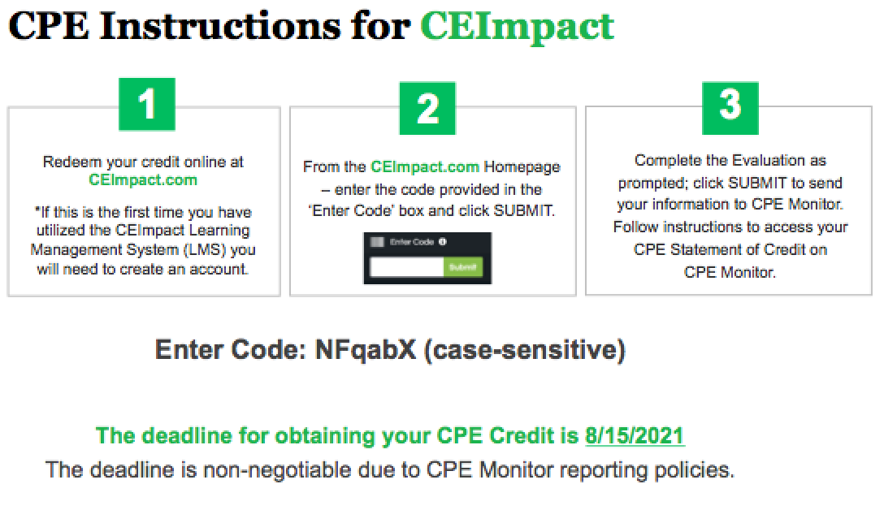
- J Cobb Scott, Stacia Woodcock, Brian Essenter, Laura Borgelt, Bonni Goldstein, Dustin Sulak, Kareem Abdalla, Christine Roussel, and Laszlo Mechtler
See you in Denver, Colorado at the Gaylord Rockies for CCPC 2021 on August 12-14!

